Name: ICT Assessment: 7E-7M Teaching Group:
 | DIGITAL LITERACY  Understanding of how to use technology safely and responsibly. | COMPUTER SCIENCE  Ability to design write and debug programs; knowledge of sequencing and logical reasoning. | INFORMATION TECHNOLOGY  Ability to demonstrate basic IT skills and use of software to explore, present ideas & solve problems | CHARACTER  Personal, social and interactive beahvour within lessons.  Holistic development.
Secure/  Mastered | I can explain numerous reasons why it is important to have an e-safety policy and I can write my own own to keep others safe.  I can demonstrate an awareness of the concequences of behaviour online, and how my digital footprint may have implications upon my future. | I can demonstrate confidence in writing complex code and independently transferring this onto the Micro:bit  I can use my independent enquirer skills to explore advanced features of a Micro:bit and how these can be used to enhance my work. | I can fully understand computational thinking and can explain 5 components with details and examples.  I can use the five components of computational thinking to overcome complex problems using both Psuedocode and flow charts. | I can consistently demonstrate the behaviour expected in lessons.  I can consistently strive to improve the quality of my work.
Developing | I can explain why it is important to have an e-safety polcies and how to use them.  I can describe what a digital footprint is and how to behave appropriately online. | I can with assistance demonstrate my ability to write intermediate code and transfer this onto the Micro:bit.  I can identify different components of the of the Micro:bit and describe its functionality. | I can explain the term computational thinking, listing the five key components.  I can develop the ability to use computational thinking to overcome a problem using the 5 key components with Psudeocode or Flow charts. | I can avoid distracting others.  I can works hard to improve the quality of my work.
Emerging | I know what an E-safety policy is.  I am aware if some of the potential risks I may be exposed to when using the internet. | I can understand how to write simple code and with assistance transfer this onto a Micro:bit.  I can explain what a Micro:bit is and what you are able to use them for. | I can understand the term computational thinking and can discuss what it is.  I can with assistance I can use computational thinking to overcome a problem using either Pseudocode or Flow charts. | I can often stay focused on a task and I enjoy my learning.  I can makes some effort to improve the quality of my work.

REFLECTION:
Winter |  | Spring |  | Summer
Digital Literacy | /6 | Digital Literacy | /6 | Digital Literacy | /6
Computer Science | /6 | Computer Science | /6 | Computer Science | /6
Information Technology | /6 | Information Technology | /6 | Information Technology | /6
Character | /6 | Character | /6 | Character | /6
Total | / 24 | Total | / 24 | Total | / 24
My Strength: _______________  ____________________________________________________________________________________________________________  My target: _________________  ____________________________________________________________________________________________________________  I am proud of myself because:  __________________________  ____________________________________________________________________________________________________________ |  | I have improved by _____ points  My Strength: _______________  ____________________________________________________________________________________________________________  My target: _________________  ____________________________________________________________________________________________________________  I am proud of myself because:  __________________________  ____________________________________________________________________________________________________________ |  | I have improved by _____ points  My Strength: _______________  ____________________________________________________________________________________________________________________  My target: _________________  ____________________________________________________________________________________________________________________  I am proud of myself because:  __________________________  ___________________________________________________________________________________________________________________

Superhero skills used in winter term  Creative thinker  Reflective learner  Self-manager  Effective participator  Independent enquirer  Team worker | Superhero skills used in Spring term  Creative thinker  Reflective learner  Self-manager  Effective participator  Independent enquirer  Team worker | Superhero skills used in summer term  Creative thinker  Reflective learner  Self-manager  Effective participator  Independent enquirer  Team worker
What fruits of faith have you used:  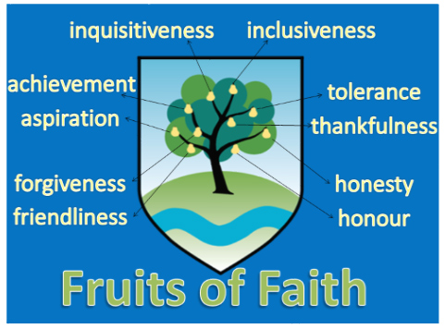 | What fruits of faith have you used: | What fruits of faith have you used:
E = 0-6 D = 7-13 S = 14-19 M = 20-24

